Ancient Religious Art

Student’s Name
Institutional Affiliations
Date
Ancient Religious Art
There is an ancient art that existed in the period between 1CE to 1300CE. Majorly, these arts represented religious information using symbols to represent or communicate a certain message. This report will analyze one of the ancient Christian art that existed between 1CE to 1300CE. The report will analyze the aspects of symbolism presented in the art.
One of the common Christian art is the crucifix. The crucifix is a presentation of art that Christians mostly use, especially Catholics. The crucifix represents early art used by the catholic church, representing a cross with a corpus crucified on the cross. However, some Christian only uses the cross without the corpus on it(Nichols, 2016). The cross is found in ancient roman catholic cathedrals hanging on the walls of the cathedral. The figure is 74.5 by 74cm by size. the art was produces after the death of Christ during the establishment of the Roman catholic. The art was found after the death of Christ, where the Christians used the cross to symbolize the death of Christ.
The crucifix represents a T-shaped cross and a body crucified on the cross, some form of ancient writings on the top of the cross, and some women standing beside the cross. See the figure below,
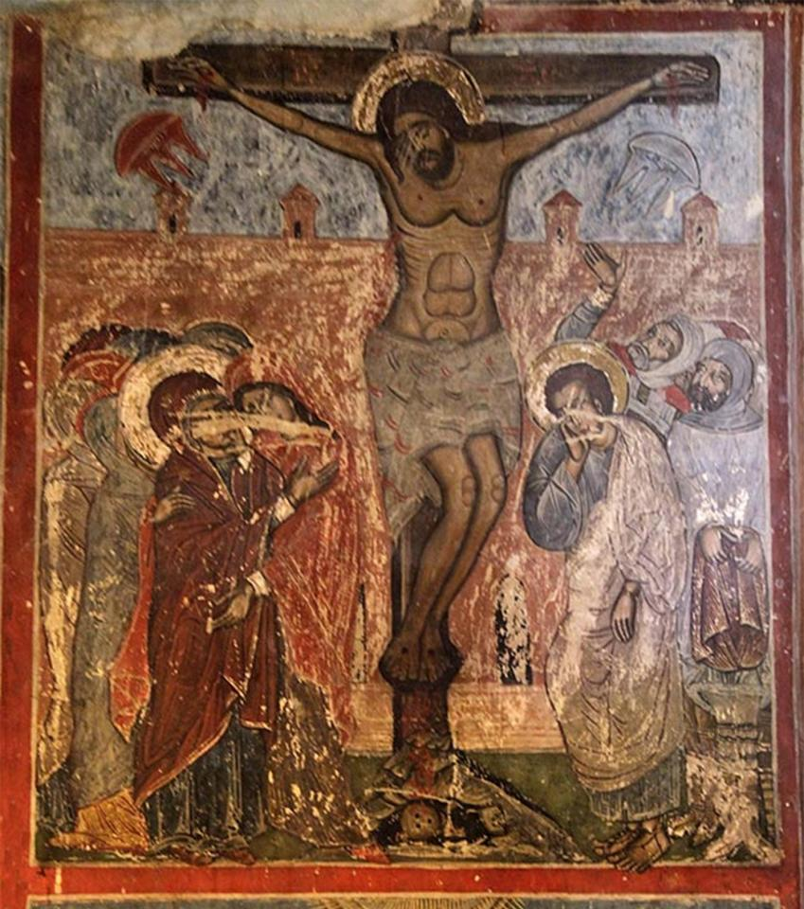
This art is found in the scholarly journals written about the early art of Christians. The crucifix is a Christian religious art that presents several pieces of information about the Christian religion. The crucifix symbolically communicates to the Christian about the Messiah's death, whom they believe in having died for their sins. Some of the common symbols displayed by the catholic church include the T- cross. The cross in the Christian crucifix symbolizes a seal between the Christians and the lord. However, there are several messages that the cross displays in the Christian religion. One of the common messages is a representation of the lord in the presence of people (Laureti et al., 2019). The Christians believe that the cross in the crucifix means that God is present among us. In other words, the cross symbolizes a message of God with us.
The symbol of women standing beside the cross symbolizes how Christians had mercy on the crucified Christians. Women standing beside Christ on the cross symbolizes that Christians should pray through Christ to forgive their sins.
Further, the Christian cross represents the symbolic message of the suffering the Christ lord underwent to save the Christians and the world from sins. The cross represents the body of Christ, who died on the cross to save the sins of man (Clague, 2017). The cross represents the history of the Christian religion. Further, the cross acts as a reminder of the suffering Christ underwent.
The crucifix also contains some Greek writing on top of the cross using Greek numerals. The writing on the cross represented the king of Jews. The writing symbolizes that Christy is the lord and the king of the Jews (Brubaker, 2017). The Christians interpret the writing on the cross as the holy and leadership of Jesus Christ, crucified on the cross. The ancient Christians in Rome believed that Jesus, who was crucified on the cross is the king of all that exists.

References
Brubaker, L. (2017). In the beginning was the Word: Art and Orthodoxy at the Councils of Trullo (692) and Nicaea II (787). In Byzantine Orthodoxies (pp. 95-101). Routledge.
Clague, J. (2017). Symbolism and the Power of art: Female representations of Christ Crucified. In Bodies in Question (pp. 29-55). Routledge.
Laureti, S., Colantonio, C., Burrascano, P., Melis, M., Calabro, G., Malekmohammadi, H., ... & Pelosi, C. (2019). Development of innovative integrated techniques for paintings examination: The case studies of The Resurrection of Christ attributed to Andrea Mantegna and the Crucifixion of Viterbo attributed to Michelangelo's workshop. Journal of Cultural Heritage, 40, 1-16.
Nichols, A. (2016). The art of God incarnates Theology and image in the Christian tradition. Wipf and Stock Publishers.

